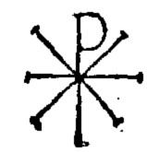

What Do You Believe?

What Are Good Works?
OT: Micah 6:6-8 | John 15:1-11

Immanuel Kant | Rich Young Ruler
Universal Laws | Burnt Offerings / Sacrifices
Approval | “In Jesus’s Name”

- How can “good” be objectively defined?

- What are ways we can know what God approves?

- What does the story of the Rich Young Ruler tell us about law-keeping?

- What does it mean to do everything “in the name of Jesus?”

- What does a branch that yields good fruit look like in comparison to its trunk?

